I started to test the reports but I am really worried because:

I reviewed commission report, then I approved a commission, because I want to print it and review he report again but I approved the commission, but then I go to print the commission and don’t show the agent.

I reviewed again and the commission is approved and don’t printed

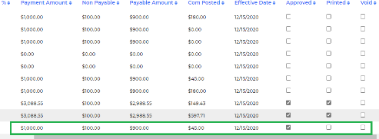

But the commission doesn’t show for print

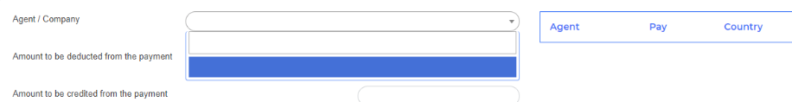

This was working, so at this point if the functionalities don’t working now I can’t test the reports. I need to do things in the system and that this work correctly to review in the reports. 1/14/2021

>>> Fixed. Please check and confirm. 15 JAN 2021

This part is working but now I created a payment and approved one commission for Hector Bistre

I reviewed the commissions repot and shows

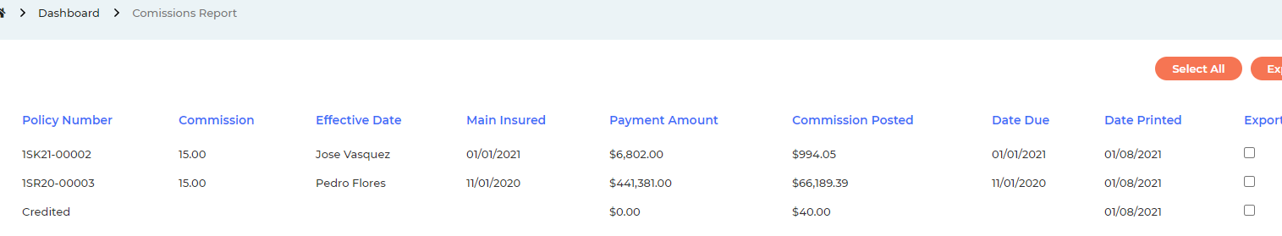

And then I went to WT to print the one commission that I approved but shows 2 commissions and I didn’t add some credit, but it’s showing a credit? 1/15/2021.

>>> Done. Please check and confirm. 15 JAN 2021

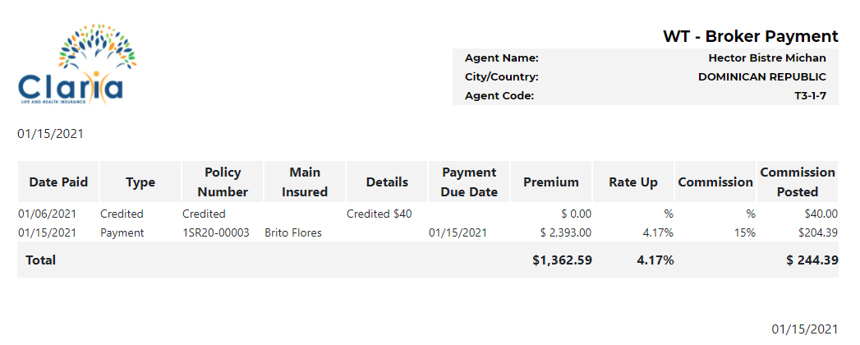

Ok, but now in WT are showing 2 Agents in $0

>>> Done. Please check and confirm. They were there because of the wrong commissions created with 0 values. 19 JAN 2021

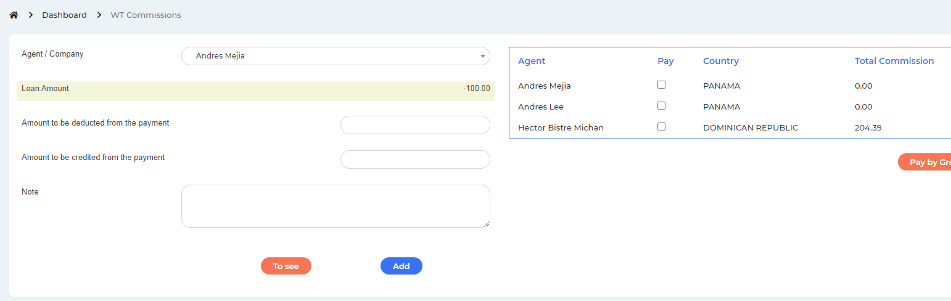

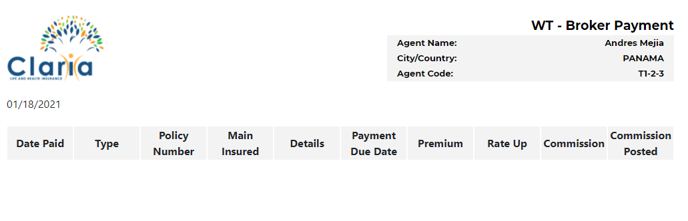

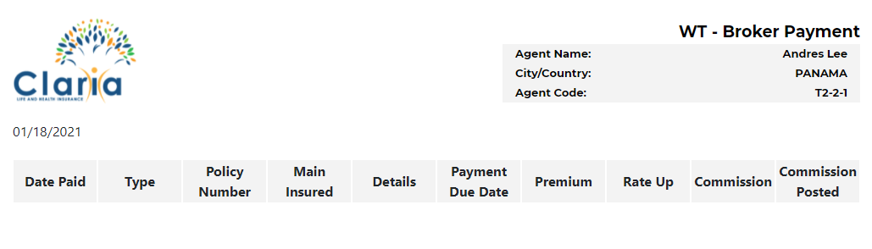

And if I review Andres Mejia, it shows empty the report? So if don’t have commissions to pay why is showing? 1/18/2021

>>> Done. Please check and confirm. They were there because of the wrong commissions created with 0 values. 19 JAN 2021

Ok 1/19/2021

In pending commission the titles have arrow but it’s not working to order the column 

>>> Please note that it is not possible with php to sort every column like you can do in access. Only some of the columns can have sorting functionalities. No sorting functionalities had been added to the titles on any of the commissions report as it was not mentioned in the scope of the commission. We can work on it later by making a list of columns that can be sorted. 19 JAN 2021

Please even add order by policy number 1/19/2021

>>> Yes, we will go through that after finishing the original scope. We will take a list of columns from you that you want to sort and implement sorting functions to the columns that are possible. 20 JAN 2021

Thanks 1/20/2021

show more lines in each page 1/18/2021

>>> Done. Please check and confirm. 19 JAN 2021

>>> If you find anymore issues here, we will fix that. But please read the full document to make the review process faster as there are some information about reports that we need from you.

I go through the whole document, but there are some reports that I can't test until everything works in Main.

For example I want to review commission report, I created a new policy, payments, approved a commission, I created a credit but don’t show the two commissions to pay (see document test-loans) 1/19/2021

>>> Done. Please check and confirm. 20 JAN 2021

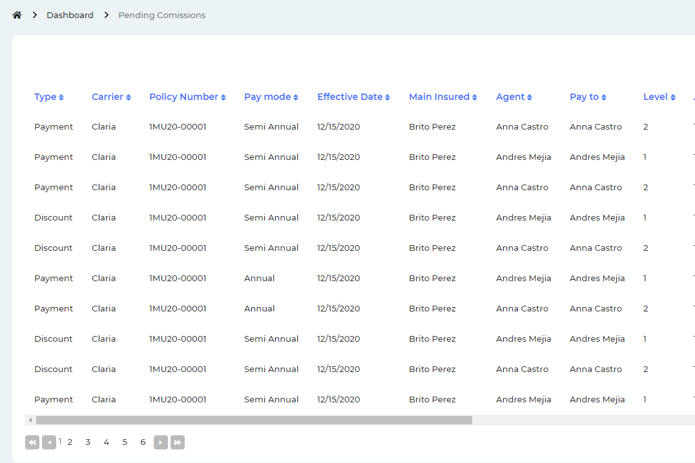

1. **New system:  <<Reports>>**

<<Commissions report>>  wrong calculations

>>> Commissions calculation part done. Please check and confirm. 12 JAN 2021

I don't know if the report works well because the commission part is not working well. 1/19/2021

>>> Done. Please check and confirm. 20 JAN 2021

Other issue found (see document test-loans) if the commissions part is not working. I’m not sure if the report is ok 1/20/2021

>>> Done. Please check and confirm. 26 JAN 2021

<<Payment Control>>

1. **Pending include agent name**: Level 1;   Level 2;  Level 3;  Level 4;

>>> Done. Please check and confirm. 12 JAN 2021

OK 1/19/2021

1. **Pending include menu for each column**: << Filter of information>>

>>> What will be the functionality of that filter menu? 12 JAN 2021

According to what you indicate in php you cannot filter everything, but you do need filters for at least some fields. Without this, it is not easy to handle all the information that the reports throw up. 1/19/2021

>>> We need to know in detail that what type of sorting functionality you want here. There is no explanation about that in the video. 20 JAN 2021

If I send the columns you do it now or after? I confused? 1/20/2021

>>> Please send us the columns. We will implement it after as I explained above. 21 JAN 2021

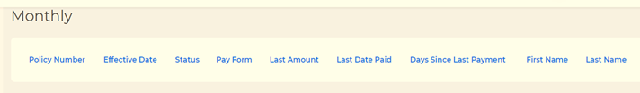

**Current System: <<Reports>>**

Note that each column have an option menu for filter the information

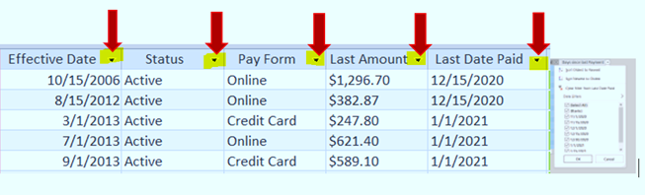

1. Commission Report

Select Andres Mejia 12/1/2020 until 1/31/2021

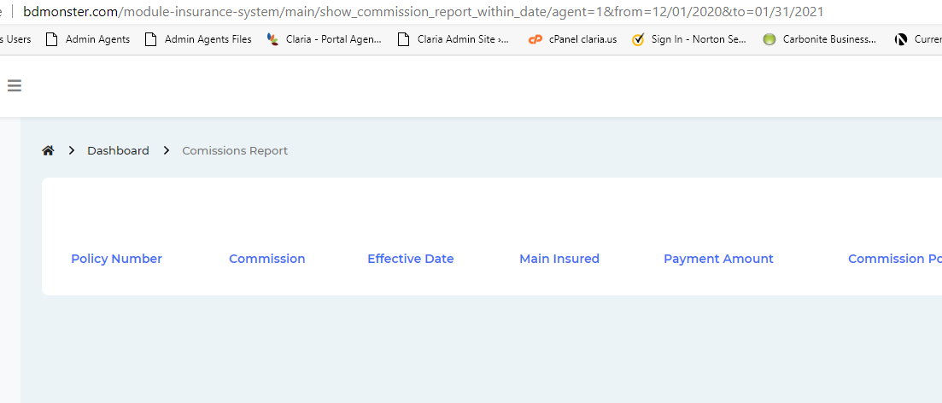

Don’t show any info

>>> Fixed. Please check and confirm. 14 JAN 2021

Correct the titles Effective Date and Main Insured are inverted

>>> Done. Please check and confirm. 20 JAN 2021

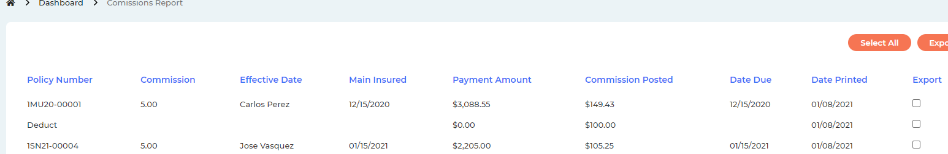

Is not showing the agent and dates selected

>>> Done. Please check and confirm. 20 JAN 2021

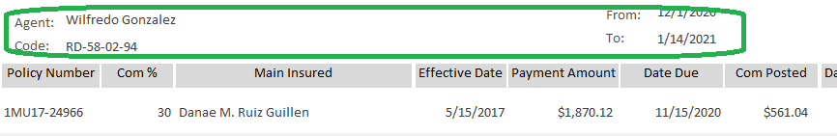

Jan 14/2021

I can’t test this report the commissions are not working, it’s showing a commission that I didn’t pay 1/19/2021

>>> Done. Please check and confirm. 20 JAN 2021



Other issue found (see document test-loans) if the commissions part is not working. I’m not sure if the report is ok 1/20/2021

OK 1/22/2021

1. New Business Report

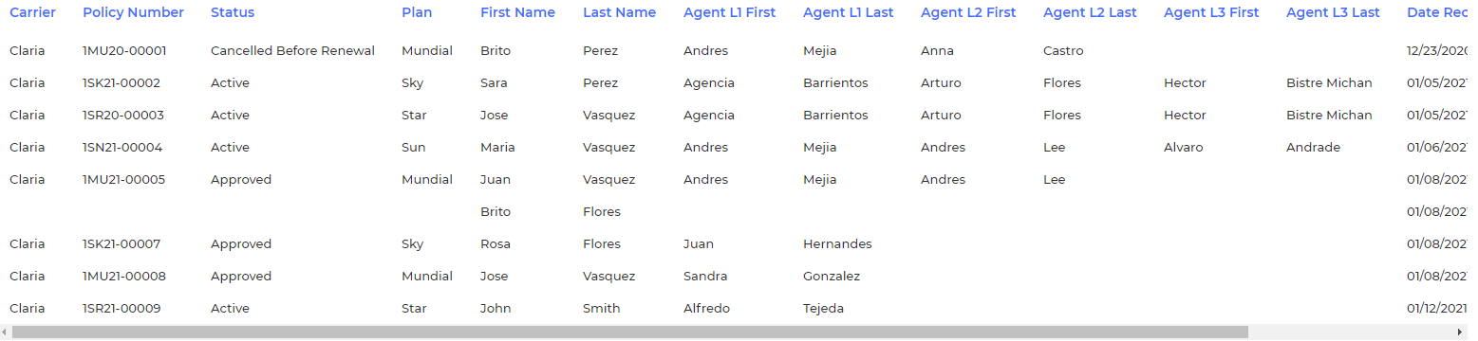

I saw the policy 00006 was not created in the system is, and when I review the report is showing a policy without number, please verify why create a policy without policy number is important validate this and not created policies that really doesn't work.

>>> Fixed. Please check and confirm. 14 JAN 2021

In which order is showing the information, put an order to the reports not as the system brings them, you can please sort it by creation date. 1/19/2021

>>> Done. Please check and confirm. 20 JAN 2021

Ok 1/20/2021

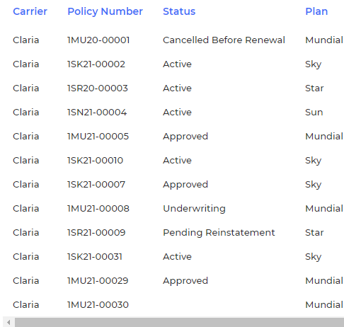

New business by doctor is not available

>>> In the video it was mentioned that New business by doctor is not needed. Please check the video and confirm. 14 JAN 2021

OK 1/19/2021

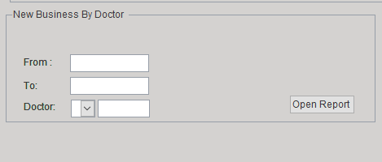

It’s not showing the first and last name 1/29/2021

>>> Done. Please check and confirm. 20 JAN 2021

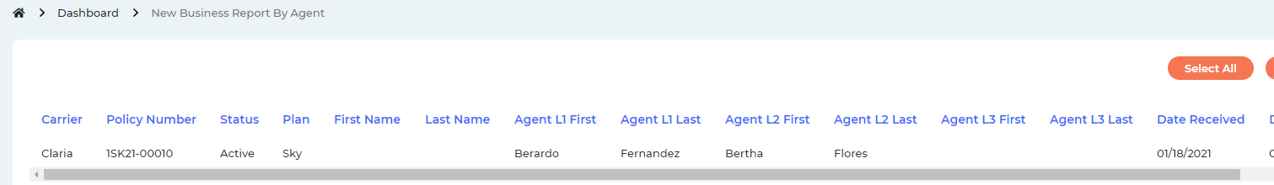

Doesn’t work 1/20/2021



>>> Done. Please check and confirm. 21 JAN 2021

Ok 1/22/2021

1. Active Business Report

Only must to show the next status

"Active" Or "Pending Renewal" Or "Pending Reinstatement"

>>> Done. Please check and confirm. 14 JAN 2021

No working

>>> This is working. You have posted the screenshot of New Business Report. And this point is for Active Business Report. Please check and confirm. 20 JAN 2021

I didn’t report that issue in 1/19/2021 (see the color of font), is an old comment 1/21/2021

>>> So, it is working. Please confirm. 21 JAN 2021

Yes, it’s ok 1/22/2021

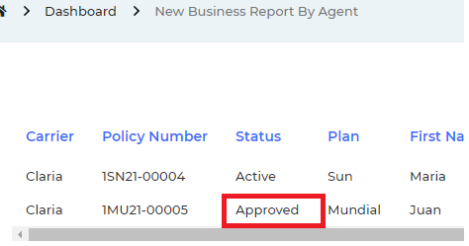

Some fields are not showing in the report

>>> Done. Please check and confirm. 14 JAN 2021

| **agent full reports l1** | | | | | | | | | | | | | | |
| --- | --- | --- | --- | --- | --- | --- | --- | --- | --- | --- | --- | --- | --- | --- |
| **Policy Number** | **LastOfStatus** | **LastOfPay Cycle** | **LastOfEffective Date** | **LastOfAgent L1** | **LastOfAgent L1 L** | **LastOfAgent L2** | **LastOfAgent L2 L** | **Agent L3** | **Agent L3 L** | **LastOfFirst Name** | **LastOfLast Name** | **LastOfMaxOfDate Paid** | **LastOfLastOfAmount** | **LastOfLastOfPolicy Fee Amount** |
| 1EL08-01009 | Pending Renewal | Quarterly | 1/1/2008 | Abraham | Podgursky |  |  |  |  | Matilde | Babani de Bessudo | 10/6/2020 | $0.00 | $0.00 |
| 1EL08-01051 | Pending Renewal | Semi annual | 2/15/2008 | Abraham | Podgursky |  |  |  |  | Gabriel | Calderon Yermia | 9/14/2020 | $0.00 | $0.00 |



It’s not showing the same fields

>>> It’s showing the same fields as you posted above. Please check and confirm. And let us know which field is missing. 20 JAN 2021

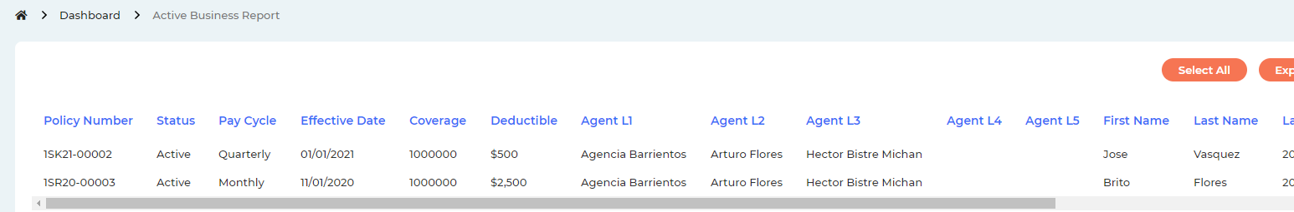

Coverage and Deductible are not fields in this report 1/20/2021

>>> Done. Please check and confirm. 21 JAN 2021

Ok 1/22/2021



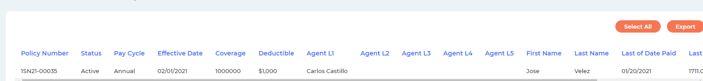

The dates are not in the format that I have requested. PLEASE ALWAY IN ALL mm/dd/yyyy 1/19/2021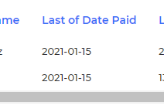

>>> Done. Please check and confirm. 20 JAN 2021

Ok 1/20/2021

1. Payment Report

By Date Created

The field user is not present when I consult the report

Don’t show info

>>> Done. Please check and confirm. 14 JAN 2021

Ok 1/19/2021

By Date paid

By Date Created

The field user is not present when I consult the report

>>> Done. Please check and confirm. 14 JAN 2021

Ok 1/19/2021

Is not showing all field

>>> Please send column list that needs to be displayed. It is not readable in the image below. 14 JAN 2021





Fields to show, include the dates that use to filter and footer 1/19/2021

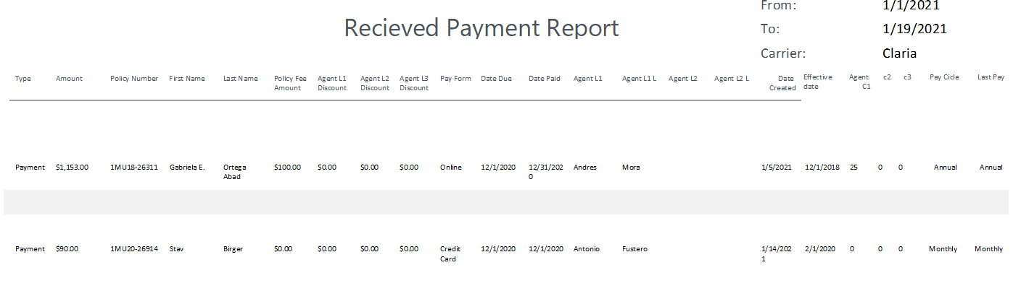

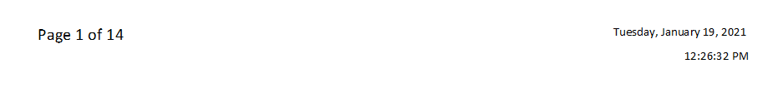

Still the same 1/20/2021

>>> Done. Please check and confirm. 21 JAN 2021

Still the same 1/22/2021

>>> Done. Please check and confirm. 26 JAN 2021



1. Payments by Policy

Show the user name no id

>>> Done. Please check and confirm. 14 JAN 2021

lack agent L4 Discount 1/19/2021

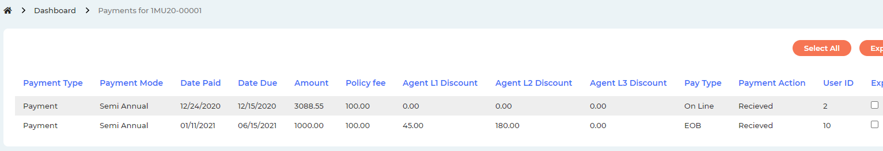

Still the same, I can’t find more comments of January 20 so I checked until here 1/20/2021

>>> Done. Please check and confirm. 21 JAN 2021

OK 1/22/2021

1. Inclusion Report

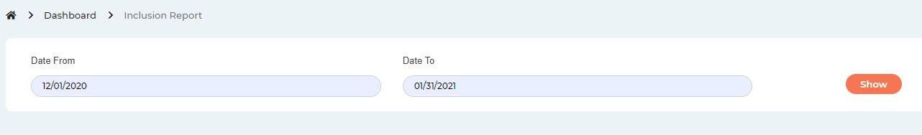

When click in show does nothing, if there is no info to show let it be known in a message, because it seems that it did nothing

>>> Done. It will take you to the report page whether there is data available or not. Please check and confirm. 14 JAN 2021

Ok 1/19/2021

When I try to add an insurance fro try the inclusion I saw the age is not correct show -1 must to show 0

>>> Done. Please check and confirm. 14 JAN 2021

Ok 1/19/2021

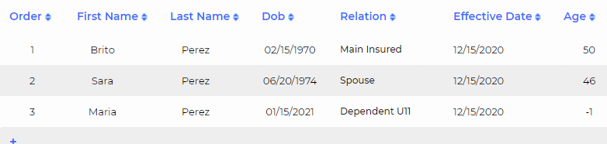

Is not showing all fields

>>> Done. Please check and confirm. 14 JAN 2021

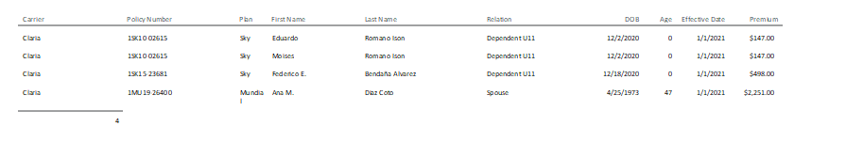

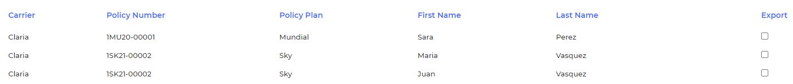

The relation field lack

>>> Done. Please check and confirm. 21 JAN 2021 OK 1/22/2021

It is showing everything created, the inclusions are the insured who are added after the policy has been created and the insured has a date after the first effective date of the policy

>>> Done. Please check and confirm. 21 JAN 2021 OK 1/22/2021

Add the head and footer, this apply for all reports 1/19/2021

>>> Done. Please check and confirm. 21 JAN 2021 OK 1/22/2021

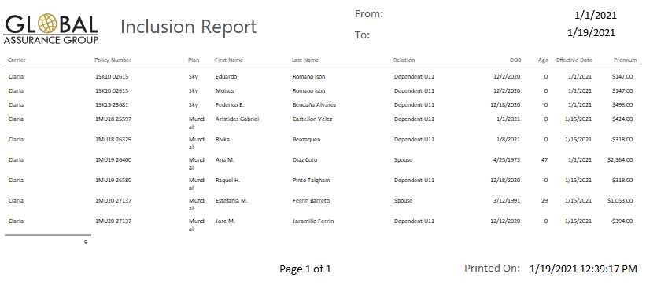

1. Info Agents

When export the info is not showing info in CK,DD,WT,L1,L2,L3,L4,L5

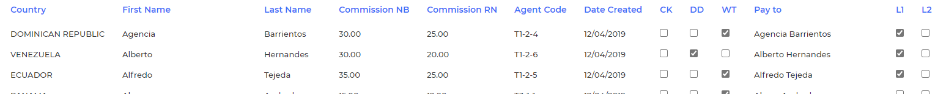

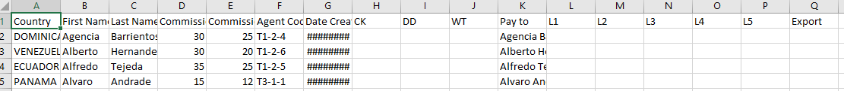

Review that in al exports

>>> Done. Please check and confirm. 14 JAN 2021

Ok 1/19/2021

1. Policies without Insured

Ok

1. Policies cancelled

Not show all the info

>>> Done. Please check and confirm. 14 JAN 2021

Ok 1/19/2021

The part of the notes is not present

>>> Done. Please check and confirm. There was no instruction about notes in the video. 14 JAN 2021

The notes are not the cancellation, is the notes of the each policy, if the policy has more than one note, it must show all notes 1/19/2021

>>> Done. Please check and confirm. 21 JAN 2021

I think is not the best way to show the notes, if I have a lot of policies with a lot of notes, is not organized to see. Please when the user selects a policy, maybe you can put a check in the first column and if have that checked show the note in the right side. 1/22/2021

>>> Done. Please check and confirm. 26 JAN 2021

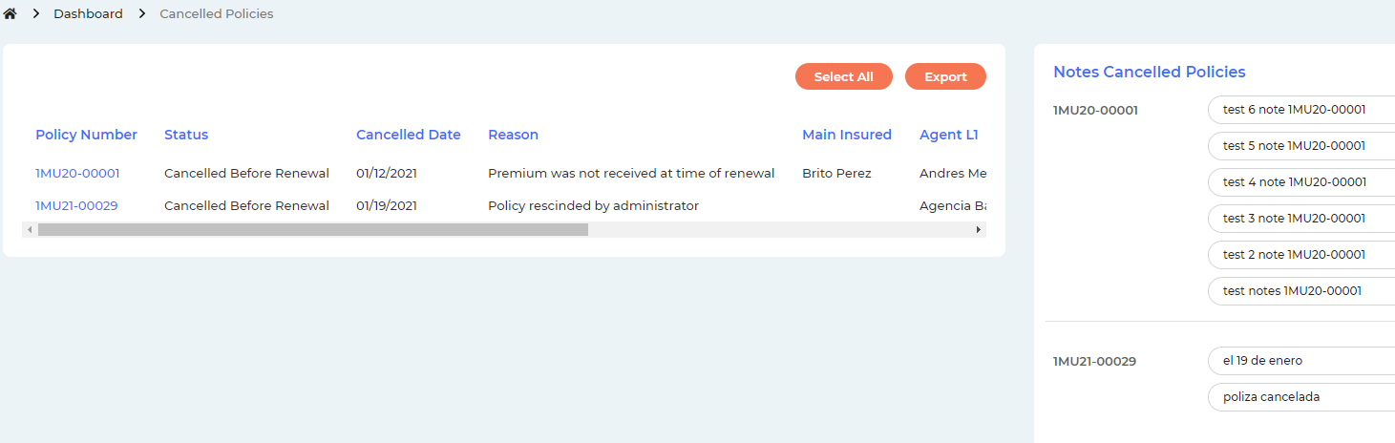

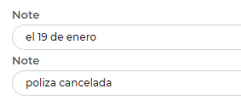

The link to go at the policy is not available

>>> Done. Please check and confirm. 14 JAN 2021 Ok 1/19/2021

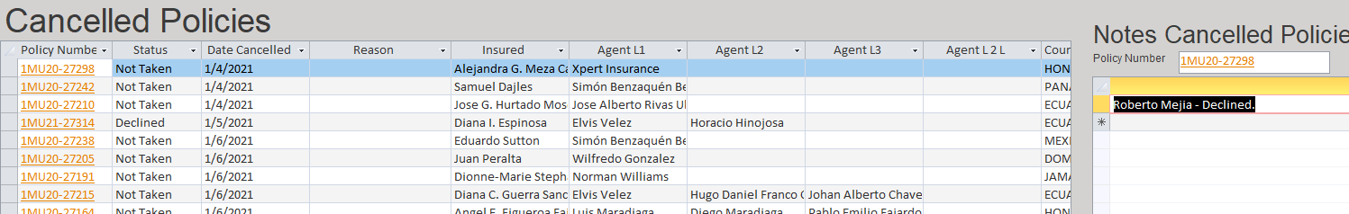



1. Policies claria express

Is not available

>>> In the video it was mentioned that she is not sure if that report is needed or not. Therefore there was no instruction about that. Please check and confirm if you need it. And what will be this report if you need it? 14 JAN 2021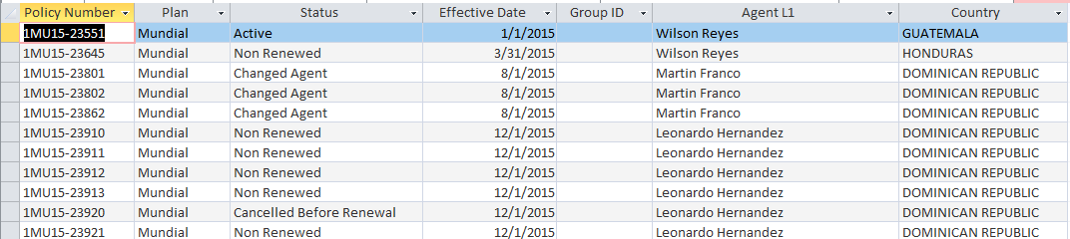

We need it. 1/19/2021

>>> Please let us know what will be displayed in this report. As I said there was no instruction about this report in the video and you did not explain it as well. 21 JAN 2021

The policies that have the Claria Express checked 1/22/2021

>>> Done. Please check and confirm. 26 JAN 2021



Until here I reviewed there is no more response with current date 1/22/2021

1. Pending payment control

Is not showing the title

>>> Done. Please check and confirm. 14 JAN 2021

Ok 1/19/2021

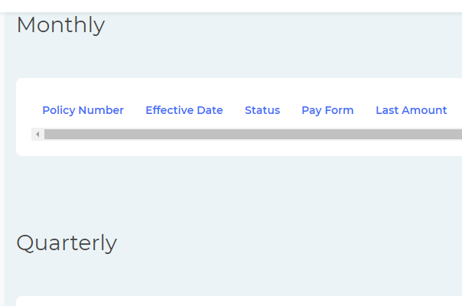

If show that numbers is because in the report must to show 5 expired monthly, 9 expired semi annual ..

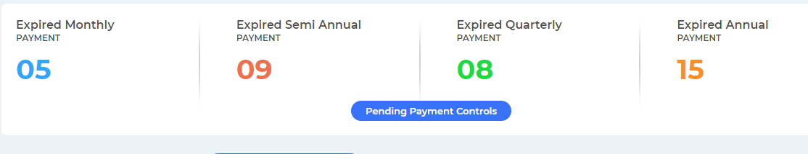

But I enter and don’t show info

The statics are equal to the info in the report

>>> Done. Please check and confirm. 14 JAN 2021

Is not showing info I created the policy 1SR21-00009 and it’s not in monthly options

>>> Only the policies that has payment in pending status are listing here. If the there is no payments under that policy then it will not be displayed here. This is the current query. Please let us know if it is not correct and what should be the correct query? 14 JAN 2021

From where

It’s not the payments pending, are the payments that do not exist

I really send the access database, if you want to see the queries could you review in that? there are many queries 1/19/2021

>>> Done. Please check and confirm. 26 JAN 2021

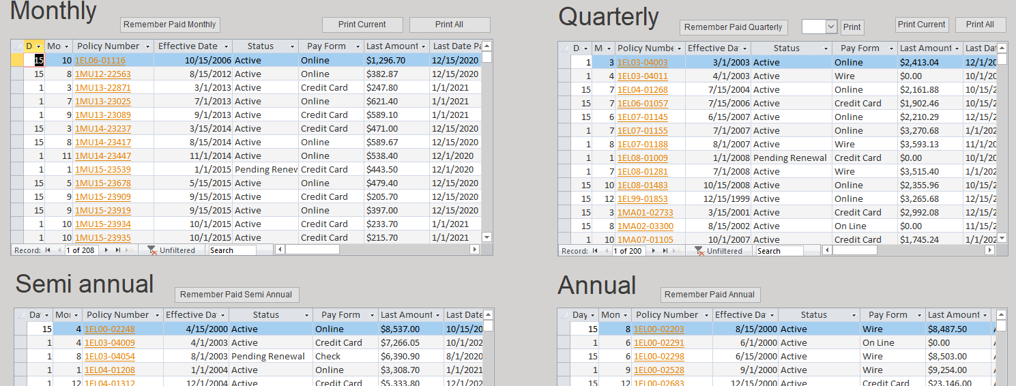

The options to print are not available

>>> Done. Please check and confirm. 14 JAN 2021

I can’t test, it’s not showing info 1/19/2021

>>> Done. Please check and confirm. 26 JAN 2021

Remember put the link to go at the policy is not available

>>> Done. Please check and confirm. 14 JAN 2021

I can’t test, it’s not showing info 1/19/2021

>>> Done. Please check and confirm. 26 JAN 2021

Remember put the colors in the print option

>>> Please let us know the date duration for the colors. It is not mentioned in the video. 14 JAN 2021

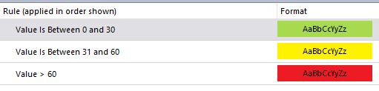1/19/2021

>>> Done. Please check and confirm. 26 JAN 2021

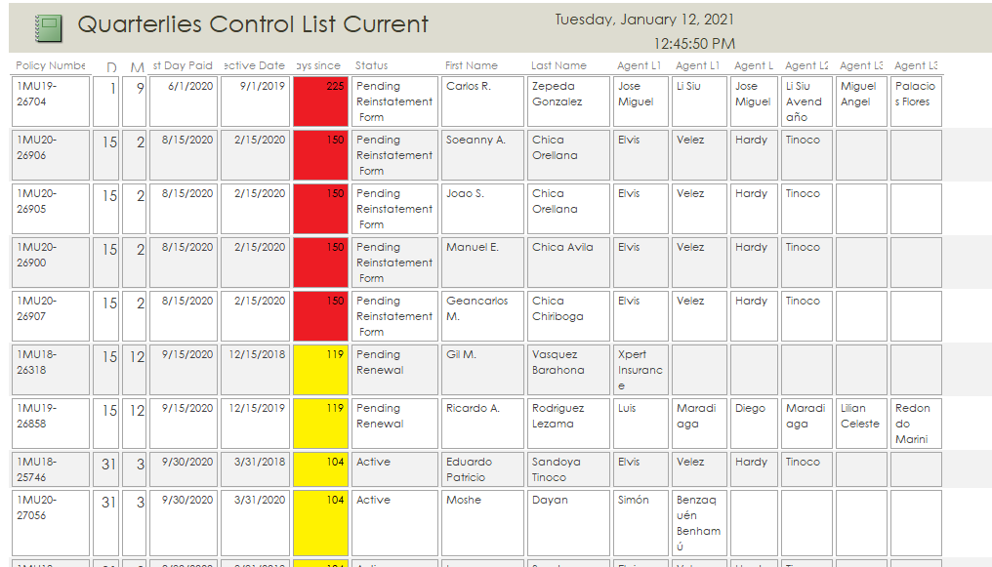

1. Pending payments by agent

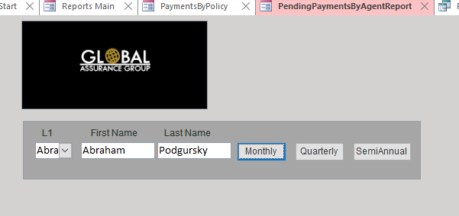

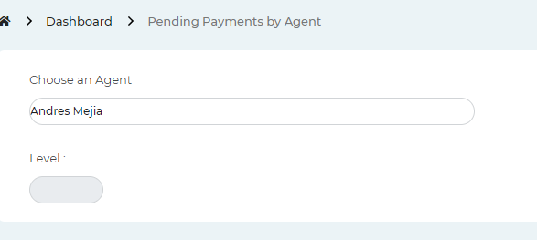

is not showing the monthly, quarterly and semiannual options

>>> Done. Please check and confirm. 15 JAN 2021

OK 1/19/2021

select the agent Alfredo Tejada and don’t show the payment pending

>>> Because there is no payments in pending status under that agent in the database. Please check and confirm. 15 JAN 2021

It’s not the payments pending, are the payments that do not exist 1/19/2021

>>> Done. Please check and confirm. 26 JAN 2021

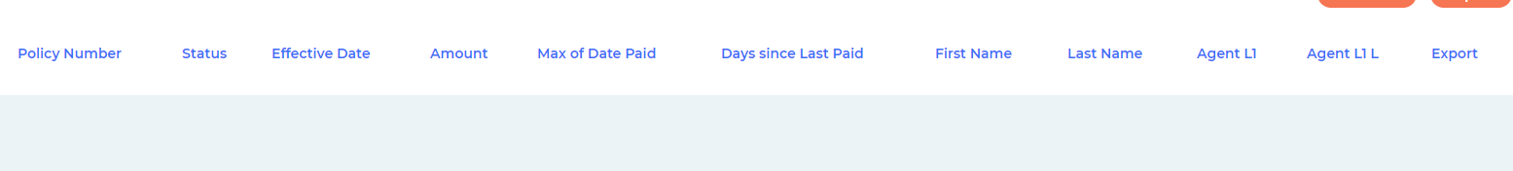

1. Pending renewals

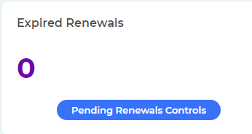

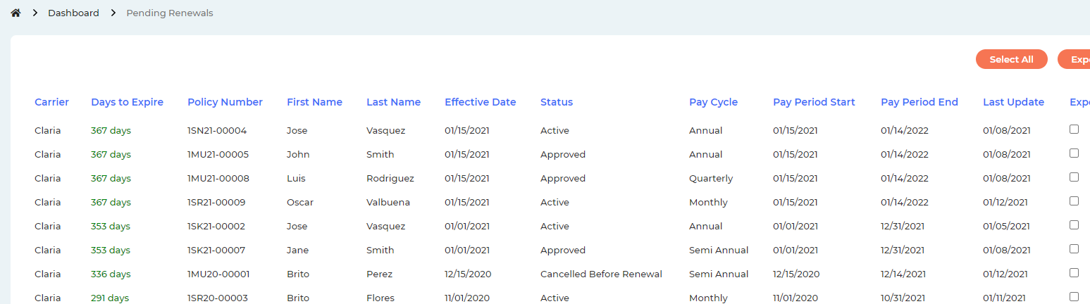

The link in the policy number to go at the policy is not present

>>> Done. Please check and confirm. 14 JAN 2021 ok 1/19/2021

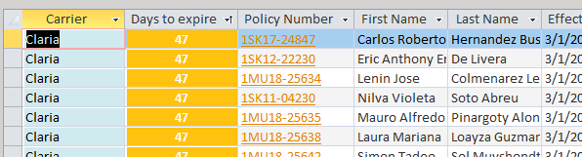

It’s working 1/19/2021

Please review the color if it’s like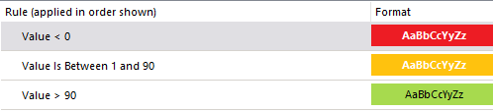

>>> Done. Please check and confirm. 26 JAN 2021

1. Pending Underwriting Control

The statistics is not working show in all 5 and it’s not real,

>>> Done. Please check and confirm. 14 JAN 2021

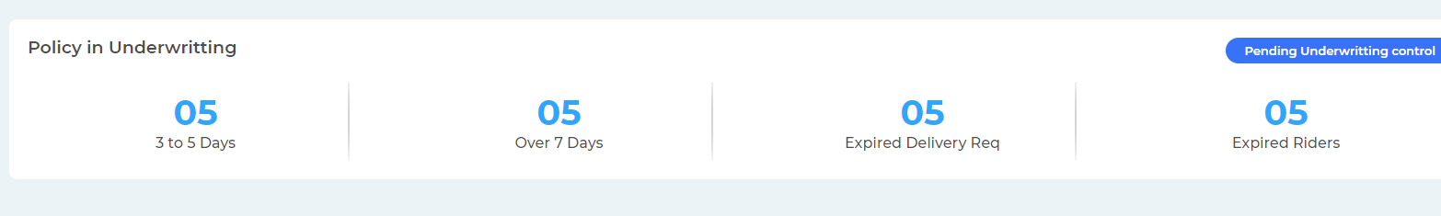

1 policy 1MU21-00030 is in underwriting since 01/01/2021 and it doesn’t show in the statistics and report

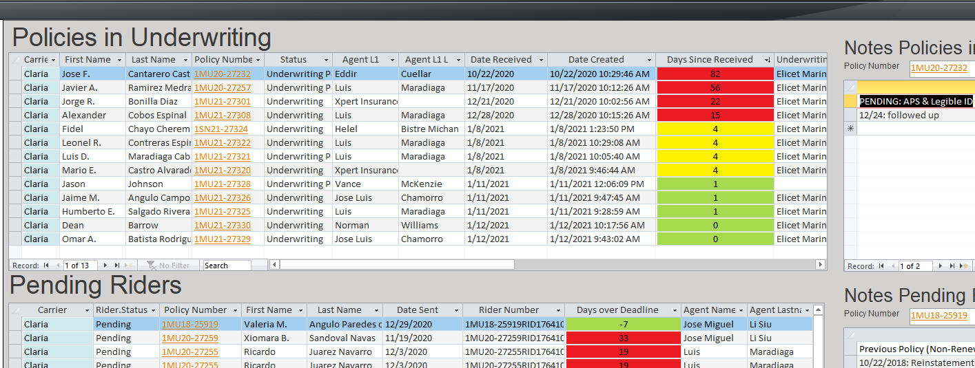

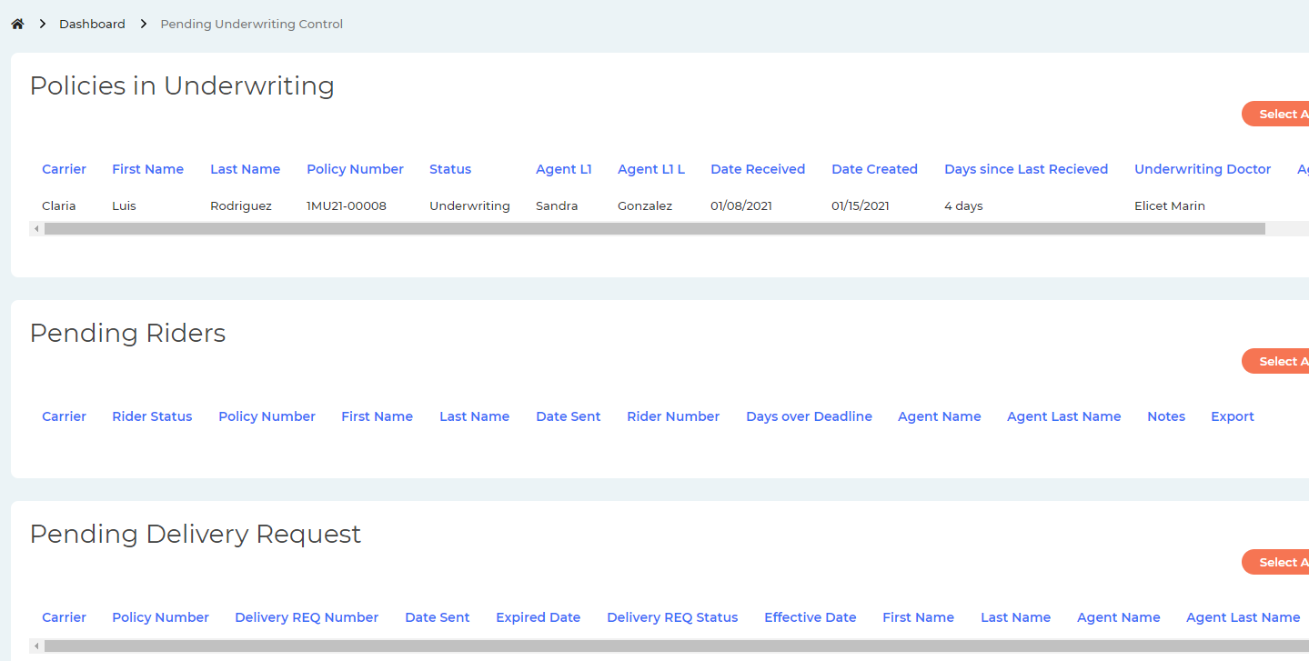

Is not showing the dates with color

>>> Please let us know the date duration for the colors. It is not mentioned in the video. 14 JAN 2021

Underwriting 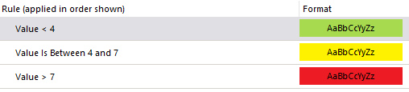

Pending riders 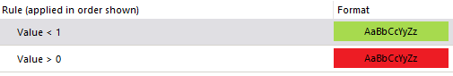

Pending delivery request 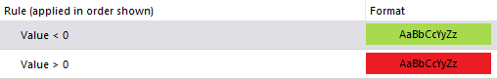

Pending approved 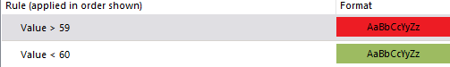

Pending reinstatement 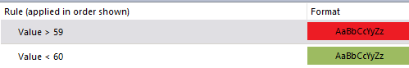

The notes is not a field, must to be separate because can be more than one note

>>> Done. Please check and confirm. 14 JAN 2021

The notes are the policy, not the cancellation. It must show all notes. 1/19/2021

The link to go at the policy is not present

>>> Done. Please check and confirm. 14 JAN 2021

Ok 1/19/2021

In pending riders is not showing info

>>> Done. Please check and confirm. 14 JAN 2021

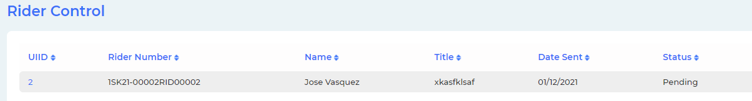

Agent L2 is not a field in this reports

>>> You sent Agent L2 column for this report in “Fields Reports_31Dec2020.xlsx” file. Please check and confirm. 14 JAN 2021

Yes I send in that excel, but now I review in the interface and it’s not showing, please hide it 1/19/2021

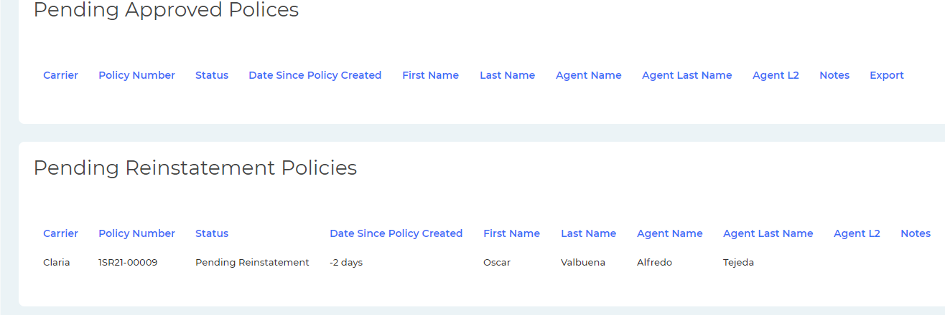

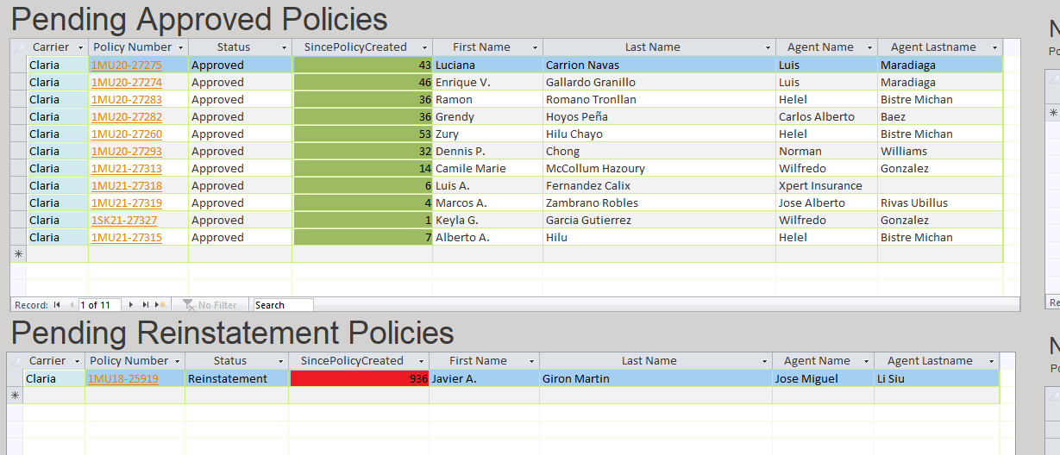

Please verify is a lot of thing to fixes. Review all.

The field notes should not show in the left side 1/19/2021

